Multi-Task Deep Learning for Food Recognition and Nutrition Estimation from Asian Food Images
Received: 20 June 2026; Revised: Accepted: xxxx; Available online: xxxx
Abstract: In recent years, monitoring nutritional intake has become increasingly important for promoting healthy dietary habits and reducing the risk of diet-related diseases. Maintaining a healthy lifestyle requires the consumption of nutritionally balanced foods. This research presents a deep learning–based end-to-end multi-task learning framework for simultaneous food recognition and nutrition estimation from 2D food images of Asian food. A cleaned and augmented subset of the NutritionVerse-Real dataset was used, focusing on 42 common food types after removing incomplete classes. The proposed architecture used a shared convolutional neural network backbone with two prediction branches: a multi-label classification head which uses sigmoid activation to identify food components inside a dish and a regression head to estimate nutritional values at the dish level. The model is trained using a weighted combined loss function that combines weighted binary cross-entropy for food classification and Huber loss for nutrition regression in order to efficiently balance the two learning tasks. Two convolutional neural network backbones, MobileNetV2 and ResNet-50 were evaluated as feature extractors within this multi-task framework. The experimental results show that the MobileNetV2 achieved competitive performance with a micro precision of 0.5100, micro recall of 0.5424, and Hamming accuracy of 0.9146 for food recognition. In addition, MobileNetV2 demonstrated more consistent nutrition estimation performance, achieving positive R² values across all nutritional targets, ranging from 0.0419 for calories, 0.0701 for fats, 0.1356 for protein, 0.2620 for carbohydrates, and 0.5541 for sodium. In contrast, ResNet50 produced negative R² values for calories, fats, and protein despite achieving stronger food recognition performance. The results highlight the potential of multi-task deep learning models for simultaneous food recognition and nutrition estimation while also revealing the challenges of accurately predicting certain nutritional attributes from 2D food images. These findings provide a foundation for future automated dietary monitoring systems and further research on image-based nutrition assessment.
Keywords: Asian Food Dataset; Deep Learning; MobileNetV2; Multi-Task; Nutrition Prediction; ResNet-50

- INTRODUCTION
The increasing prevalence of diet-related diseases such as obesity, diabetes, and cardiovascular conditions has led to growing interest in automated food calorie estimation systems [1]. Traditional methods require manual logging of meals, which is time-consuming and error-prone [4, 7]. With the advancement of computer vision and deep learning, image-based calorie estimation has become a promising approach to understanding eating behavior and supporting health-conscious decisions [3, 6].
Although much progress has been made in image-based food classification, most research and datasets focus on Western cuisines [7]. Asian dishes are more complex, frequently mixed, contain multiple ingredients, and lack consistent presentation styles [5]. Datasets such as Food-101, UECFOOD100, and Food-50 do not capture the visual diversity of Asian dishes, resulting in poor performance when applied to Cambodian or regional cuisines [5, 7].
In Asian contexts, dietary habits are diverse, and existing calorie estimation systems often perform poorly due to lack of representation of Asian cuisine in global datasets [5]. This study bridges this gap by developing an end-to-end deep learning framework for food recognition and calorie estimation using 2D images, focusing on Asian foods. The objective is to develop accurate and lightweight models that can perform efficiently in real-time systems. Specifically, this study aims to:
- Develop an end-to-end multi-task deep learning model that simultaneously performs food recognition and dish-level nutrition estimation from food images.
- Compare the performance of different CNN backbones (MobileNetV2 and ResNet50) within the proposed multi-task framework.
- METHODOLOGY
2.1 Proposed Methodology
This study proposes an end-to-end multi-task deep learning framework for simultaneous food recognition and nutrition estimation from food images [6]. Instead of using separate models for each task, the proposed approach utilizes a shared convolutional neural network backbone to learn unified visual representations, followed by two prediction branches [3]. The backbone network is based on pre-trained convolutional architectures, including MobileNetV2 [8] and ResNet-50 [9], which are fine-tuned on the target dataset. The shared feature extractor processes the input image and generates high-level visual features that are used by both tasks [6,7].
The first branch is a multi-label classification head designed to identify multiple food components within a single dish. A sigmoid activation function is applied to allow independent probability estimation for each food class. To address class imbalance, a weighted binary cross-entropy loss function is used.
The second branch is a regression head that predicts dish-level nutritional values, including calories, fats, carbohydrates, protein, and sodium. This branch uses fully connected layers with a linear activation function and is trained using the Huber loss to improve robustness against outliers.
To jointly optimize both tasks, a combined loss function is employed:
$L_{Total}=w_{1}L_{WBCE}+w_{2}\sum_{k=1}^{5}{L_{Huber, k}}$ (Eq. 1)
Where,
$L_{Total }$is the overall training loss
$L_{WBCE }$is the weighted binary cross-entropy loss for classification task
$L_{Huber,k }$is the Huber loss for $k^{th}$ nutrition target
$w_{1}$is fixed at 0.7
$w_{2}$is scaled based on the number of regression targets which is 0.06
Fig.1 proposed multi-task framework: shared CNN backbone with classification and regression branches. The pipeline starts with an input food image. Overview of the proposed multi-task learning framework for simultaneous food recognition and nutrition estimation. The input food image is processed by a shared convolutional neural network backbone to extract visual features. These features are then fed into sigmoid activation to predict food components, and a regression head to estimate dish-level nutritional values.
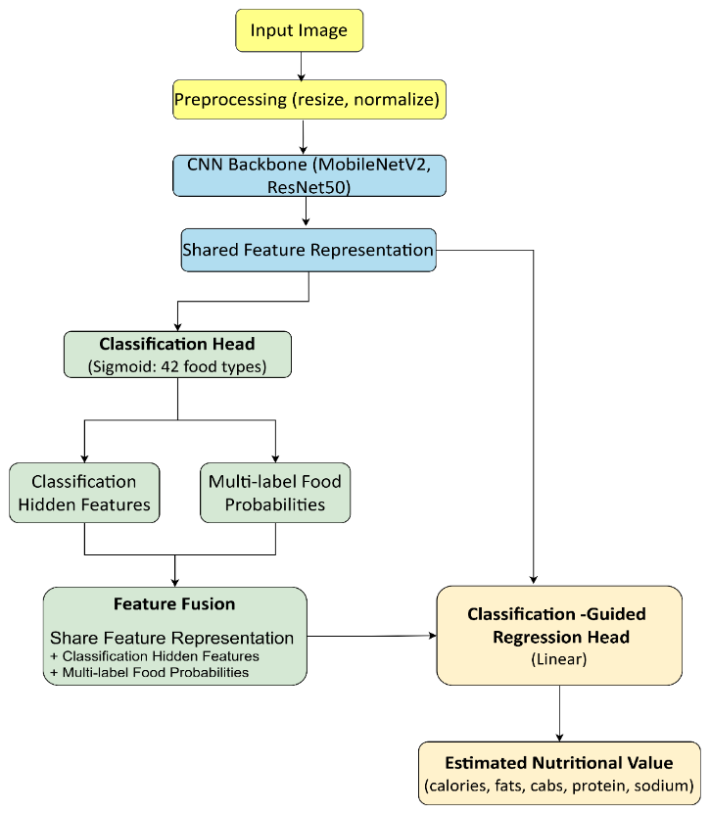
Fig. 1. The proposed flowchart for food image analysis and nutritional value estimation flow
2.2 Dataset
This study uses the NutritionVerse-Real, an open access manually collected 2D food scene dataset for dietary intake estimation with 889 images of 251 distinct dishes and 45 unique food types which contains real Asian dishes captured from multiple angles which each dish id have 4 images corresponding with nutritionverse_dish_metadata3 file which included dish_id, food_item_type, food_weight(g), calories(kCal), fat(g), carbohydrates(g), protein(g), calcium(mg), iron(mg), magnesium(mg), potassium(mg), sodium(mg), vitamin_d(µg), vitamin_b12(µg) [5]. Fig. 2 provides details of the food class distribution of the original data.
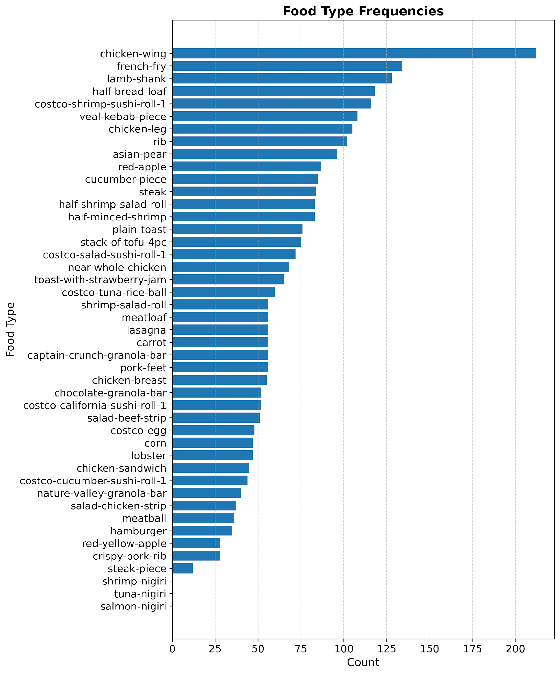Fig. 2. Food class distribution of original Data.
Fig. 3 provides the example dishes from NutritionVerse-Real datasets.

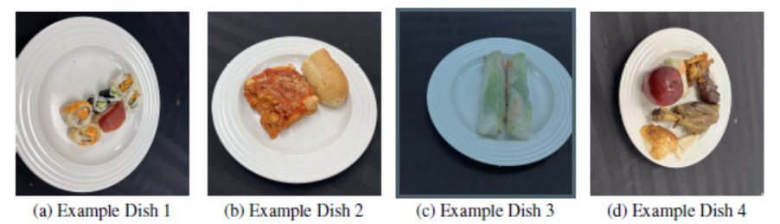
Fig. 3. Example dishes from NutritionVerse-Real
2.3 Feature Engineering and Data Preprocessing
The data were further processed to extract meaningful features and ensure suitability for model training. The dataset provides dish-level metadata, ingredient-level nutritional information, and corresponding food images [5]. Before model development, the raw data required systematic cleaning and restructuring to ensure consistency, reliability, and suitability for machine learning tasks [4, 6]. The preprocessing process was required to cover an end-to-end multi-task deep learning framework for simultaneous food recognition and nutrition estimation from food images.

2.3.1 Dataset Filtering and Final Sample Selection
The original metadata file records up to seven food items per dish using variable-length columns. To standardize this for machine learning, a fixed list of 45 food types was curated to define the complete label space for multi-label classification. For each dish, missing values were replaced with empty strings, and a structured food-type vector was generated by incrementing corresponding columns whenever a match was found. This produced a cleaned dish-level metadata table containing only the dish_id and the 45 binary food-type indicators.
To ensure the reliability of the training process, a systematic filtering step was performed to verify the presence of valid image references for every dish in the metadata. Images were loaded and verified using the Python Imaging Library (PIL); dishes lacking valid images were excluded to prevent mismatches. After cleaning incomplete classes and missing metadata, the study obtained 889 original images across 42 food classes. The final dataset includes multi-label annotations representing ingredient presence, along with comprehensive nutritional metadata including food weight (g), calories (kCal), fat (g), carbohydrates (g), protein (g), and various micro-nutrients such as calcium, iron, and vitamins. During this process, three specific classes with insufficient data; salmon-nigiri, shrimp-nigiri, and tuna-nigiri were removed to maintain statistical significance. Fig. 4 provides details of the food class distribution after dropping missing matches and refining the metadata.
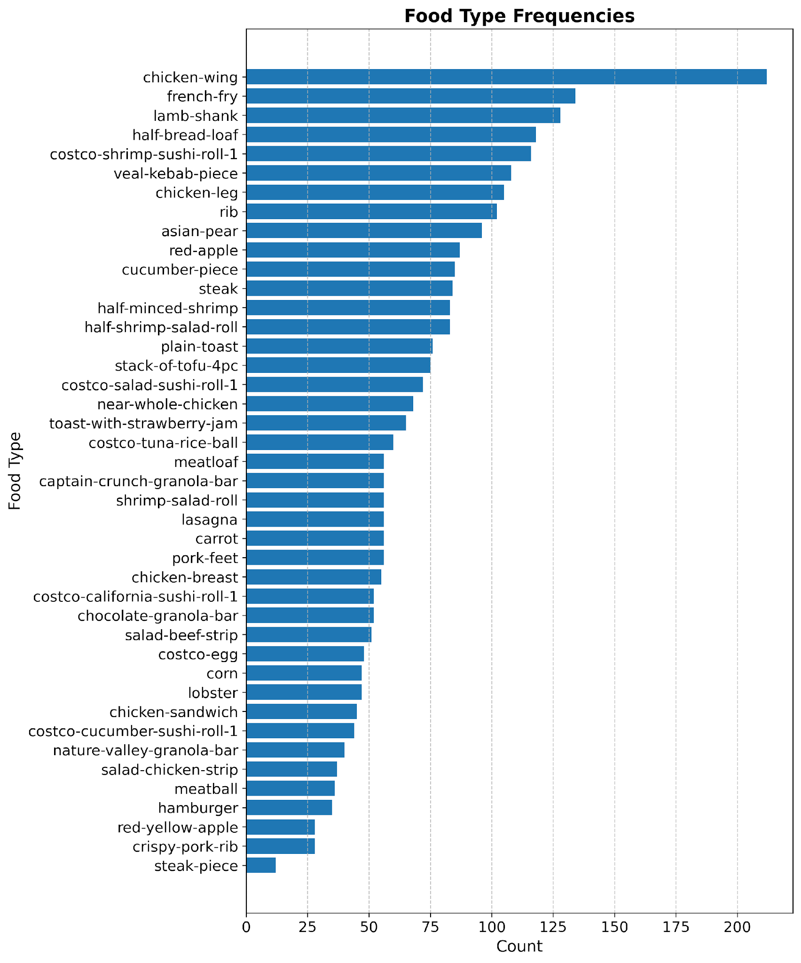
Fig. 4. Food class distribution after dropping the missing match.
2.3.2 Image-Based Feature Extraction and Dataset Filtering
Each dish in the dataset is associated with multiple food images captured from different viewpoints. However, for metadata-level feature extraction, only the presence of at least one valid image per dish was required. To incorporate basic visual characteristics, two global image features were extracted from the first available image associated with each dish: Aspect ratio is the proportional relationship between width and height and Average pixel intensity means the average value of all individual pixel intensities.

$AR =\frac{Width}{Height}$ (Eq.2)

$API=\frac{1}{N}\sum_{i=1}^{N}{I_{i} }$ (Eq.3)
Where,
$AR$is aspect ratio
$API$ is average pixel intensity
$N$ is total number of pixels
$I_{i}$ is intensity of pixel i

These features were included as supplementary image descriptors. However, their individual contribution to predictive performance was not separately evaluated, as the primary learning signal was derived from CNN-extracted visual features.
Images were loaded and verified using the Python Imaging Library (PIL). If no valid image was found for a given dish, that dish was excluded from further analysis to prevent mismatches between metadata and image data. After this filtering step, a cleaned metadata file generated, containing only dishes with valid image references. Each row in this file represents a single dish and includes:
- Dish identifier
- 42 food-type indicator columns
- Nutrition value of each 42 food-type indicator columns
- Aspect Ratio
- Average Pixel Intensity
This dataset serves as the foundation for an end-to-end multi-task deep learning framework for simultaneous food recognition and nutrition estimation from food images and data augmentation in later stages.
2.3.3 Data Augmentation
In this process, a target minimum of 30 training samples per food type was set. Food categories with fewer than this threshold were selected for augmentation. This threshold was chosen as a practical balance between improving class representation and avoiding excessive duplication of training data. Before performing any augmentation, the dataset was split into training (80%), validation (10%), and test (10%) sets at the dish level, rather than at the image level. Data augmentation was applied only to training images that contained minority food classes. For each minority class, existing training images were randomly sampled with replacement until the desired number of samples was reached. To prevent excessive duplication from a single source image, a maximum number of augmented images per original image was enforced. Each augmented image was generated by applying a random combination of the following transformations:
- Horizontal flipping, applied with a fixed probability
- Random rotation within a limited angular range
- Random zooming, followed by resizing to preserve original dimensions
- Brightness adjustment
After augmentation, class counts were recomputed for the training set to verify that minority food types met or exceeded the target sample threshold. A comparison of class frequencies before and after augmentation was generated to document the effectiveness of the balancing process. In addition, class weights were calculated based on the final class distribution. These weights were later used during model training to further mitigate residual imbalance by assigning higher loss penalties to underrepresented food types. Fig. 5 provides details of class frequency between training and testing sample.
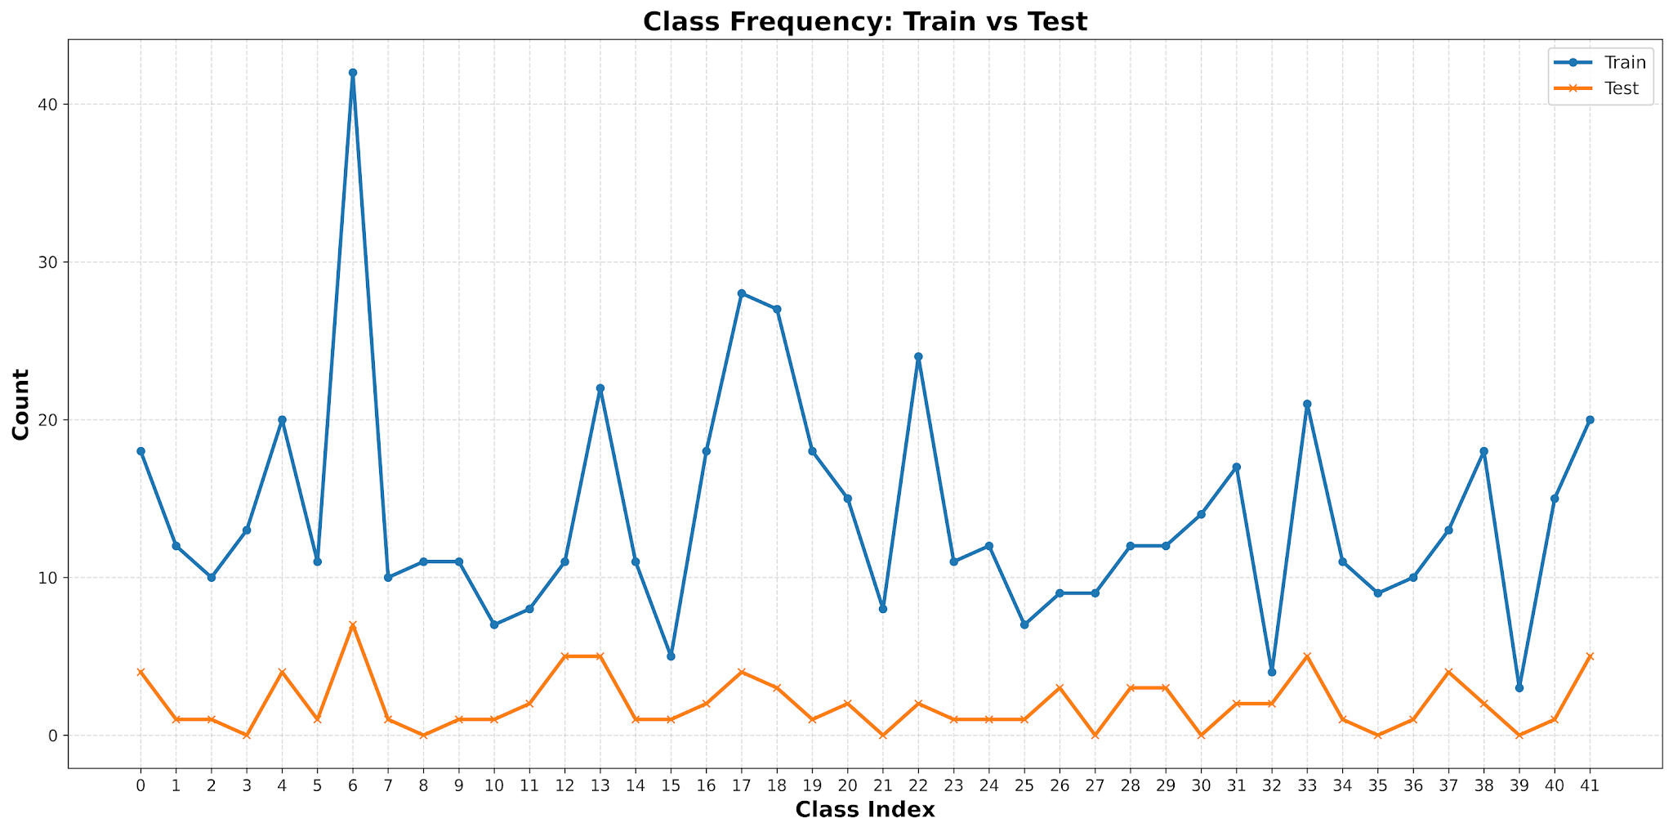Fig. 5. Food class distribution frequency of training and testing.
2.4 Model Architecture
The proposed architecture follows a shared-feature multi-task design. A convolutional neural network backbone extracts image features, which are then fed into two parallel branches. The classification branch predicts the presence of food components using sigmoid activation, while the regression branch estimates nutritional values using fully connected layers. This design enables the model to leverage shared representations for both tasks, improving overall efficiency and learning performance.
2.4.1 Mobile NetV2 Model
MobileNetV2 architecture was adopted as a lightweight and efficient feature extractor for the proposed multi-task learning framework. Pretrained weights on ImageNet were utilized to leverage transfer learning, enabling the model to extract meaningful visual representations from food images despite the limited dataset size. The final classification layer of the MobileNetV2 was removed, and the remaining convolutional layers were used as a shared backbone. The extracted feature maps were passed through a global average pooling layer, followed by batch normalization and fully connected layers to generate compact feature embeddings. These shared features were then fed into two parallel branches:
- A multi-label classification head: consisting of fully connected layers with sigmoid activation, to predict the presence of multiple food items in a single dish.
- A regression head: combining the shared visual features with the predicted class probabilities (label-conditioned input) to estimate dish-level nutritional values.
During training, the model was conducted into two stages. In the first stage, MobileNetV2 backbone was fully frozen and only the two branch heads were trained, allowing the classification and regression layers to stabilize before any backbone weights were updated. In the second stage, the last 20 convolutional layers of the backbone were unfrozen and fine-tuned jointly with both heads at a lower learning rate, enabling the shared feature extractor to adapt progressively to the food image domain. Each branch is supervised by its own loss function: the classification head is trained with Weighted Binary Cross-Entropy (WBCE) where per-class weights are computed from the training distribution to penalize misclassification of minority food types and the regression head is trained with Huber loss, which balances sensitivity to small errors with robustness to outliers in the nutritional targets. To unify both objectives into a single training signal, these two losses are combined as defined in Eq. 1, with the classification loss assigned a fixed weight of w₁ = 0.7 and the regression loss scaled at w₂ = 0.06 per nutritional target (0.3 in total across 5 targets). This weighting ensures that the model prioritizes learning accurate food component identification, which in turn provides richer conditioning signals for the nutrition estimation branch.
2.4.2 ResNet50 Model
To compare performance with a deeper architecture, ResNet50 was implemented as an alternative backbone within the same multi-task framework. ResNet50 utilizes residual learning to facilitate deeper feature extraction while mitigating vanishing gradient issues. Similar to MobileNetV2, the original fully connected classification layer was removed, and the remaining convolutional layers served as a shared feature extractor. The extracted feature maps were processed through global average pooling and then fed into the same dual-branch architecture consisting of a multi-label classification head and a nutrition regression head. While ResNet50 offers greater representational capacity than MobileNetV2, it also introduces higher computational complexity and a larger number of trainable parameters.
During training, a two-stage transfer learning strategy was adopted. In the first stage, the ResNet50 backbone was fully frozen and only the classification and regression heads were trained. In the second stage, the last 30 convolutional layers of the backbone were unfrozen and fine-tuned jointly with both heads using a lower learning rate. The same combined loss function defined in Eq. (1), consisting of Weighted Binary Cross-Entropy for food recognition and Huber loss for nutrition estimation, was used to optimize the network.
2.5 Evaluation Metrics
Given the multi-label nature of the food recognition task, multiple evaluation metrics were employed to provide a comprehensive assessment of model performance. Traditional accuracy is not suitable in this context, as each image may contain multiple food items and class distributions are highly imbalanced.
For multi-label food recognition, performance was evaluated using micro precision, micro recall, micro F1-score, macro F1-score, and Hamming accuracy. Micro-averaged metrics reflect overall prediction performance across all labels, while macro F1-score highlights performance on less frequent classes. Hamming accuracy measures the proportion of correctly predicted labels. In addition, per-class precision, recall, and F1-scores were analyzed to examine class-specific behavior and identify challenging food categories.
Common evaluation metrics for non-classification prediction tasks, relevant to estimated nutritional values, include Mean Absolute Error (MAE), Root Mean Squared Error (RMSE), and the coefficient of determination (R²). For this paper, we explore all metrics; however, the R² is used to decide the best fit model. The equations (Eq.4-Eq.6) illustrate how all evaluation metrics are calculated.

 | $$MAE=\frac{1}{n}Σ_{i=1}^{n}\left|y_{i}-{\hat{y}}_{i}\right|$$ |  | (Eq.4)
 | $$RMSE=\sqrt{\frac{1}{n}Σ_{i=1}^{n}{\left(y_{i}-{\hat{y}}_{i}\right)}^{2}}$$ |  | (Eq.5)
 | $$R^{2}=1-\frac{\sum_{i=1}^{n}{{\left(y_{i}-{\hat{y}}_{i}\right)}^{2}}}{\sum_{i=1}^{n}{{\left(y_{i}-{\overline{y}}_{i}\right)}^{2}}}$$ |  | (Eq.6)
Where,
$n$ is the number of observations
$y_{i}$is the actual value at $i^{th}$ data point
${\hat{y}}_{i}$is the predicted value at $i^{th}$ data point
${\overline{y}}_{i}$is the mean of actual values

Before presenting the evaluation results, Table 1 summarizes the key hyperparameter configurations used to train both models. All hyperparameters were selected based on established practices for transfer learning on small-scale food datasets and validated through preliminary experiments on the held-out validation split. The two-stage training strategy comprising an initial frozen-backbone phase followed by selective fine-tuning was adopted to stabilize early training and prevent catastrophic forgetting of ImageNet-pretrained representations. Early stopping was applied in both stages, monitoring the multi-label AUC on the validation set to avoid overfitting given the limited dataset size.

Table 1. Hyperparameter Configuration for Model Training
Hyperparameter | MobileNetV2 | ResNet50
Input Image Size | 224 × 224 × 3 | 224 × 224 × 3
Optimizer | Adam | Adam
Learning Rate (Stage 1 – Frozen) | 1×10⁻⁴ | 1×10⁻⁴
Learning Rate (Stage 2 – Fine-Tune) | 1×10⁻⁵ | 1×10⁻⁵
Batch Size | 16 | 16
Epochs (Stage 1 – Frozen) | 12 | 10
Epochs (Stage 2 – Fine-Tune) | 8 | 6
Fine-Tuned Layers | Last 20 layers | Last 30 layers
Early Stopping Monitor | val AUC | val AUC
Early Stopping Patience | 4 epochs | 4 epochs
LR Reduction on Plateau | Factor 0.5, patience 2 | Factor 0.5, patience 2
Dropout Rate (Backbone Head) | 0.40 | 0.50
L2 Regularisation | 1×10⁻⁴ | 1×10⁻⁴
Classification Loss Weight (w₁) | 0.70 | 0.70
Regression Loss Weight (w₂, per nutrient) | 0.06 | 0.06
Pre-trained Weights | ImageNet | ImageNet
- RESULTS AND DISCUSSION
3.1 Food Recognition Performance
Table 2 summarizes the key food recognition metrics for both models on the test set. The results confirm that both architectures can learn meaningful multi-label representations from food images, while also highlighting the difficulty of achieving high exact match accuracy on complex dish compositions. Macro F1-score, which reflects average per-class performance, was notably lower than Micro F1-score for both models, indicating that rare food categories continue to represent the primary challenge in this multi-label food recognition task.

Table 2. Food Recognition Performance
Metric | MobileNetV2 | ResNet50
Hamming Accuracy | 0.9146 | 0.9212
Micro Precision | 0.5100 | 0.5449
Micro Recall | 0.5424 | 0.5879
Micro F1-Score | 0.5300 | 0.5700
Macro F1-Score | 0.3700 | 0.4200

Fig. 6 shows the per-class F1-score distribution for MobileNetV2. Considerable variation in performance can be observed across food categories, with a small number of classes achieving high F1-scores and many classes exhibiting relatively low performance. This variability contributed to the model's Macro F1-score of 0.37.

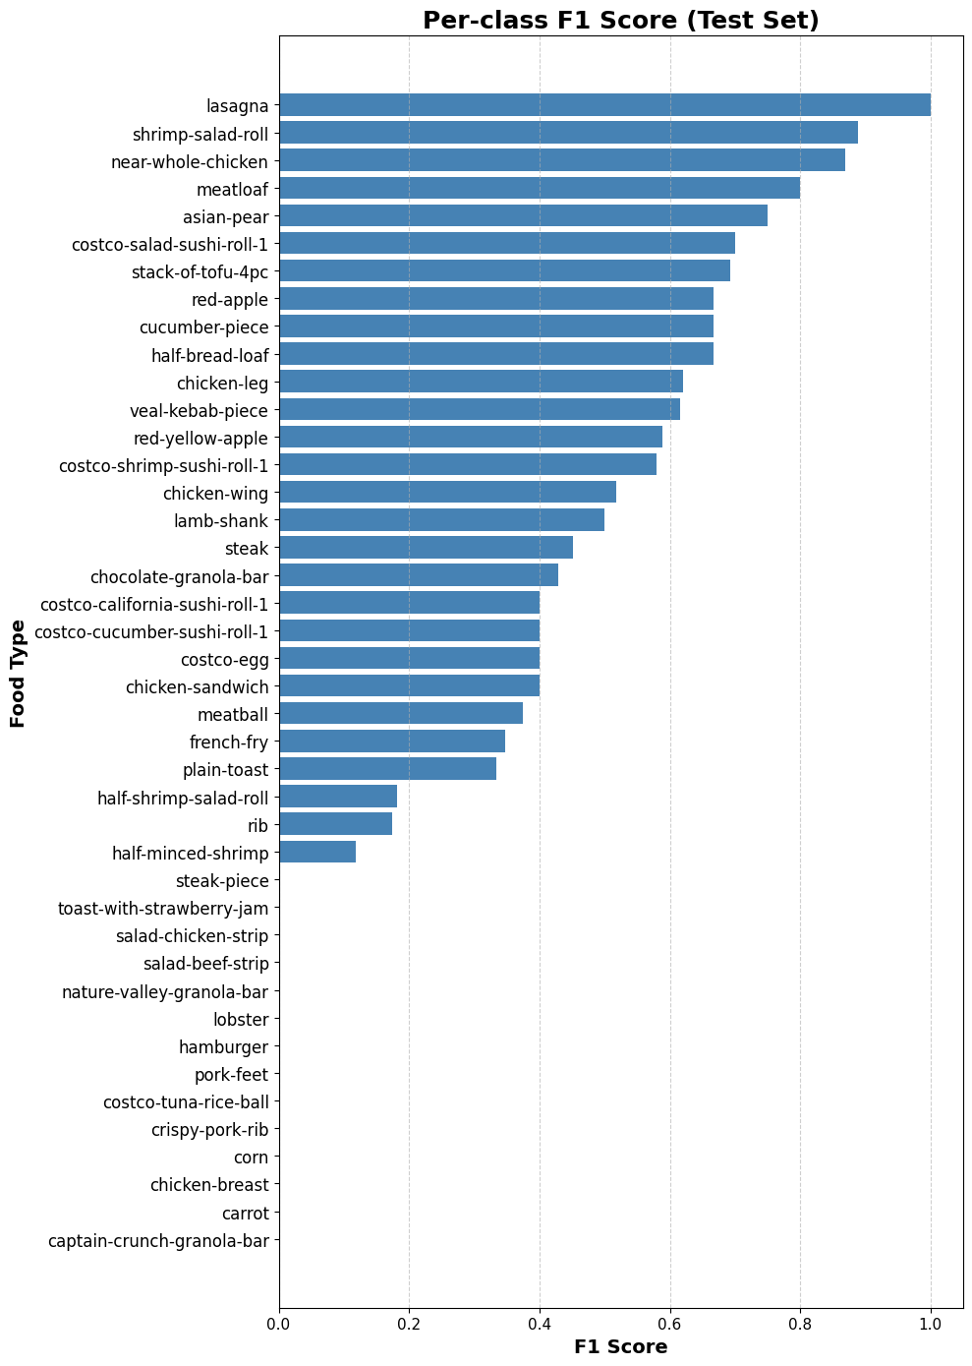
Fig. 6. Per Class F1-Score of MobileNetV2
Fig. 7 presents the per-class F1-score distribution for ResNet50. Compared with MobileNetV2, ResNet50 achieved a more balanced distribution of F1-scores across food categories, resulting in a higher Macro F1-score of 0.42 and improved class-level recognition performance.

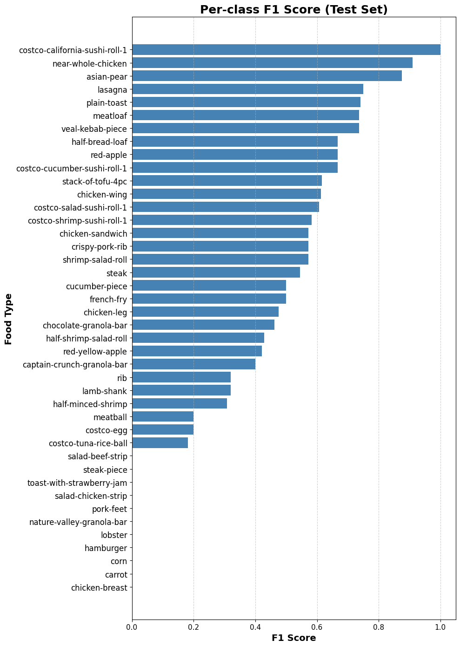
Fig. 7. Per Class F1-Score of ResNet50
To further investigate the variation in class-level performance, the top- and bottom-performing food classes for both architectures are presented in Tables 3 to Table 6.
Table 3 presents the ten highest-performing food classes for MobileNetV2 based on class-wise F1-score. Most of these classes achieved relatively high recognition performance as they exhibit distinctive visual characteristics, such as unique shapes, colors, or textures, making them easier for the model to differentiate from other food categories.

Table 3. Top 10 Performing Food Classes for MobileNetV2
Food Class | F1 Score
Lasagna | 1.00
Shrimp-salad-roll | 0.89
Near-whole-chicken | 0.86
Meatloaf | 0.80
Asian-pear | 0.74
Costco-salad-sushi-roll-1 | 0.70
Stack-of-tofu-4pc | 0.69
Red-apple | 0.67
Cucumber-piece | 0.67
Half-bread-loaf | 0.67

Table 4 summarizes the ten lowest-performing food classes for MobileNetV2. These classes achieved F1-scores close to zero, indicating that the model struggled to correctly identify them. Possible contributing factors include limited training samples, class imbalance, and visual similarities with other food categories.
Table 4. Bottom 10 Performing Food Classes for MobileNetV2
Food Class | F1 Score
Captain-crunch-granola-bar | 0.00
Carrot | 0.00
Chicken-breast | 0.00
Corn | 0.00
Crispy-pork-rib | 0.00
Pork-feet | 0.00
Hamburger | 0.00
Lobster | 0.00
Nature-valley-granola-bar | 0.00
Salad-beef-strip | 0.00

Table 5 shows the ten highest-performing food classes for ResNet50. Similar to MobileNetV2, classes with distinctive visual appearances achieved higher F1-scores, demonstrating the ability of deeper convolutional architectures to learn discriminative visual features for food recognition.

Table 5. Top 10 Performing Food Classes for ResNet50
Food Class | F1 Score
Costco-california-sushi-roll-1 | 1.00
Near-whole-chicken | 0.91
Asian-pear | 0.87
Lasagna | 0.74
Plain-toast | 0.74
Meatloaf | 0.73
Veal-kebab-piece | 0.73
Half-bread-loaf | 0.67
Red-apple | 0.67
Costco-cucumber-sushi-roll-1 | 0.67

Table 6 presents the ten lowest-performing food classes for ResNet50. Despite achieving a higher overall Macro F1-score than MobileNetV2, ResNet50 continued to struggle with several underrepresented or visually ambiguous classes, resulting in zero F1-scores for the below food class.

Table 6. Bottom 10 Performing Food Classes for ResNet50
Food Class | F1 Score
Chicken-breast | 0.00
Carrot | 0.00
Corn | 0.00
Hamburger | 0.00
Lobster | 0.00
Nature-valley-granola-bar | 0.00
Pork-feet | 0.00
Salad-chicken-strip | 0.00
Toast-with-strawberry-jam | 0.00
Steak-piece | 0.00

Both MobileNetV2 and ResNet50 achieved strong performance on visually distinctive food categories but struggled with several minority classes. The consistent occurrence of near-zero F1-scores for classes such as chicken-breast, carrot, corn, and pork-feet across both architectures suggests that class imbalance and visual similarity had an impact on performance than the choice of backbone model. Although ResNet50 improved the Macro F1-score from 0.37 to 0.42, further improvements may require larger datasets, class-balanced learning strategies, and advanced augmentation techniques.

3.2 Dish-Level Nutrition Estimation Performance
The regression head in both models was designed to receive concatenated features from the shared backbone, the classification hidden layer, and the classification output probabilities. This joint conditioning allows the regression branch to leverage food composition predictions as a prior, which is conceptually aligned with how nutritional content relates to the types of food present in a dish. Despite this architectural benefit, the R² values for calories, fats, and protein remained limited, suggesting that the visual signal from 2D images does not fully capture portion-related variance, which is a well-known limitation in image-based nutrition estimation.
Table 7 presents the regression evaluation results for both MobileNetV2 and ResNet50 across all five nutritional targets. Although the proposed framework demonstrated moderate predictive capability for certain nutrients, particularly sodium ($R^{2}=0.5541$) and carbohydrates ($R^{2}=0.2620$), performance for calories ($R^{2}=0.0419$), fats ($R^{2}=0.0701$), and protein ($R^{2}=0.1356$) remained limited. These results indicate that approximately 95.8% of the variance in calories, 93.0% of the variance in fats, and 86.4% of the variance in protein remained unexplained by the MobileNetV2 model. Furthermore, ResNet50 produced negative R² values for calories, fats, and protein, indicating prediction performance worse than a simple mean-value baseline.
The limited regression performance can be largely attributed to the inherent challenges of estimating nutritional content from a single 2D food image. Nutritional values are strongly influenced by portion size and food quantity, which cannot be directly observed from monocular images. Previous studies have reported that the absence of three-dimensional information limits accurate portion estimation [2], while more recent approaches have incorporated depth prediction and volume-related features to improve nutrition estimation accuracy [3]. Although the proposed architecture leverages food classification outputs as conditioning signals for nutrition estimation, accurate food recognition alone is insufficient to recover portion-related information. Consequently, improvements in classification performance, such as those achieved by ResNet50, did not necessarily translate into better nutrition estimation performance.

Table 7. Dish-Level Nutrition Estimation Performance
Nutrient | MobileNetV2 |  | ResNet50
Nutrient | MAE | R² | MAE | R²
Calory (kCal) | 661.83 | 0.0419 | 679.66 | -0.0312
Fats (g) | 35.81 | 0.0701 | 41.55 | -0.1408
Carbs (g) | 48.63 | 0.2620 | 54.66 | 0.0301
Protein (g) | 58.94 | 0.1356 | 58.95 | -0.0669
Sodium (mg) | 0.41 | 0.5541 | 0.43 | 0.5091

3.3 Overall Discussion

Both models were evaluated holistically across two interlinked tasks: multi-label food recognition and dish-level nutrition regression. The combined loss function used during training a weighted sum of Weighted Binary Cross-Entropy for classification (weight w₁ = 0.7) and Huber loss for regression (weight w₂ = 0.06 per nutrient target, scaled over five targets) enabled joint learning while ensuring classification received the dominant training signal. This weighting strategy reflects the design priority that accurate food component identification is a necessary prerequisite for meaningful nutritional estimation.
Overall, MobileNetV2 demonstrated a more balanced multi-task profile. While its classification metrics were slightly below ResNet50, its nutrition estimation generalized more consistently across the five nutritional targets. The model’s lightweight architecture, combined with effective data augmentation and class-weighted loss, produced a practical system capable of simultaneously recognizing food components and estimating their nutritional content from a single 2D food image. ResNet50 showed stronger discrimination in food classification but did not translate this advantage into superior nutritional regression, likely due to the limited dataset size relative to its parameter count. Fig. 8 presents the sample result for dish ID 202 of our multi-task models both MobileNetV2 and ResNet50.
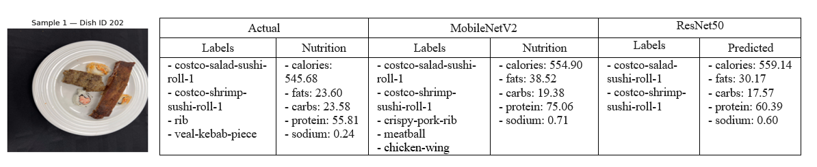
Fig. 8. Sample Output for Dish ID 202
- CONCLUSIONS
The experimental results demonstrate that MobileNetV2 achieved a Hamming Accuracy of 0.9146, Micro Precision of 0.5100, and Micro Recall of 0.5424 on the food recognition task. For nutritional estimation, MobileNetV2 achieved R² values of 0.5541 for sodium, 0.2620 for carbohydrates, and 0.1356 for protein, indicating its capability to capture meaningful nutritional patterns from visual inputs. Comparative evaluation showed that while ResNet50 demonstrated moderately stronger food classification performance owing to its deeper architecture, MobileNetV2 exhibited more consistent nutritional estimation across all five regression targets, confirming that a larger model does not necessarily guarantee superior multi-task learning outcomes on small-scale food datasets.
Key contributions of this work include the development of a multi-task architecture that conditions nutritional regression on food classification outputs, enabling the regression branch to leverage ingredient-level predictions as contextual priors; the application of targeted data augmentation exclusively to minority food classes to address class imbalance without contaminating validation and test splits; and the adoption of per-class threshold calibration on the validation set to optimize multi-label decision boundaries beyond a single global threshold. These design decisions collectively contributed to a more robust and practically applicable food analysis system.
The primary limitation of this work is the absence of depth and portion size information, which constrains the accuracy of nutritional regression particularly for high-variance macronutrients such as calories and fats. Future work should explore the integration of depth estimation modules or stereo-image inputs to incorporate volumetric information, the collection of a dedicated Cambodian or Southeast Asian food dataset to improve regional food recognition coverage, and the application of dynamic multi-task loss balancing methods to improve joint optimization performance. Transfer learning from richer food datasets or incorporating large-scale vision-language models as feature extractors also represents a promising direction for enhancing both recognition accuracy and nutritional estimation reliability.
Beyond its technical contributions, this framework aligns with and supports several United Nations Sustainable Development Goals (SDGs). Most directly, it contributes to SDG 3 (Good Health and Well-Being) by enabling automated, accessible dietary monitoring that can help individuals make more informed nutritional choices and reduce the risk of diet-related non-communicable diseases. It also relates to SDG 2 (Zero Hunger) by advancing the technological infrastructure needed for food intake awareness and nutritional equity, particularly in under-served Southeast Asian communities where reliable dietary data is scarce. Furthermore, the development of a lightweight, mobile-deployable deep learning solution supports SDG 9 (Industry, Innovation and Infrastructure) by demonstrating how advanced computer vision technology can be made accessible for practical public health applications in low-resource settings such as Cambodia. This framework therefore lays a practical groundwork for automated dietary monitoring systems that could support healthier lifestyle decisions in real-world mobile applications, with meaningful potential for positive societal impact across the region.

ACKNOWLEDGMENTS
My sincere appreciation and deepest gratitude extend to Dr. Sokkhey PHAUK and Dr. Sothea HAS for their invaluable support throughout this research. Their profound insights, exceptional expertise, and unwavering encouragement with great patience, were instrumental in not only completing this work, but also in fostering a comprehensive understanding of the subject matter. Their supervision has been a great source of direction, and I am honored to have had the opportunity to contribute to this project under their supervision.

REFERENCES
[1] World Health Organization. (2020). Healthy diet. Retrieved from https://www.who.int/news-room/fact-sheets/detail/healthy-diet Accessed: June 2026
[2] Z. Shao, S. Fang, R. Mao, J. He, J. L. Wright, D. A. Kerr, C. J. Boushey, and F. Zhu, "Towards Learning Food Portion From Monocular Images With Cross-Domain Feature Adaptation," in Proc. IEEE 23rd International Workshop on Multimedia Signal Processing (MMSP), 2021, pp. 1–6. doi: 10.1109/MMSP53017.2021.9733557.
[3] Y. Han, Q. Cheng, W. Wu, and Z. Huang, "DPF-Nutrition: Food nutrition estimation via depth prediction and fusion," Foods, vol. 12, no. 23, p. 4293, 2023, doi: 10.3390/foods12234293.
[4] C. Wimalasiri and P. K. Sahoo, "Vision-based approach for food weight estimation from 2D images," arXiv preprint arXiv:2405.16478, 2024.
[5] C. E. A. Tai, S. Nair, O. Markham, M. Keller, Y. Wu, and A. Wong, "NutritionVerse-Real: An open access manually collected 2D food scene dataset for dietary intake estimation," arXiv preprint arXiv:2310.02103, 2023.
[6] A. Oguntimilehin and G. O. Toyin, "Deep Learning-Based Food Calorie Estimation System for Dietary Tracking," 2024 IEEE 5th NIGERCON, pp. 1–6, Nov. 2024.
[7] P. Queipo-Alvarez et al., “Food Calorie Estimation Using Computer Vision: A Comparative Review of Models and Approaches,” Malaysian Journal of Medicine and Health Sciences, vol. 21, no. SUPP11, pp. 194-201, Nov. 2025.
[8] M. Sandler, A. Howard, M. Zhu, A. Zhmoginov, and L.-C. Chen, "MobileNetV2: Inverted Residuals and Linear Bottlenecks," in Proc. IEEE/CVF CVPR, pp. 4510–4520, 2018. doi: 10.1109/CVPR.2018.00474
[9] K. He, X. Zhang, S. Ren, and J. Sun, "Deep Residual Learning for Image Recognition," in Proc. IEEE CVPR, pp. 770–778, 2016. doi: 10.1109/CVPR.2016.90
[10] S. Rokhva, B. Teimourpour, and A. H. Soltani, "Computer Vision in the Food Industry: Accurate, Real-Time, and Automatic Food Recognition with Pretrained MobileNetV2," Food Humanit., vol. 3, p. 100378, 2024. doi: 10.1016/j.foohum.2024.100378
[11] J. He et al., "Multi-Task Image-Based Dietary Assessment for Food Recognition and Portion Size Estimation," in Proc. IEEE MIPR, pp. 49–54, 2020. doi: 10.1109/MIPR49039.2020.00017
[12] A. O. Adegbenjo and M. O. Ngadi, "Handling the Imbalanced Problem in Agri-Food Data Analysis," Foods, vol. 13, no. 20, Art. no. 3300, 2024. doi: 10.3390/foods13203300.
[13] F. P. W. Lo, Y. Sun, J. Qiu, and B. Lo, "Image-Based Food Classification and Volume Estimation for Dietary Assessment: A Review," IEEE Journal of Biomedical and Health Informatics, vol. 24, no. 7, pp. 1926–1939, Jul. 2020. doi: 10.1109/JBHI.2020.2987943.
[14] G. A. Tahir and C. K. Loo, "A Comprehensive Survey of Image-Based Food Recognition and Volume Estimation Methods for Dietary Assessment," Healthcare, vol. 9, no. 12, Art. no. 1676, 2021. doi: 10.3390/healthcare9121676.
[15] K. V. Dalakleidi, M. Papadelli, I. Kapolos, and K. Papadimitriou, "Applying Image-Based Food-Recognition Systems on Dietary Assessment: A Systematic Review," Advances in Nutrition, vol. 13, no. 6, pp. 2590–2619, 2022. doi: 10.1093/advances/nmac078.

* Corresponding author: E-mail: ; Tel: +

